Ai Weiwei (1970s)
Jack Bridgford

Now an internationally acclaimed artist and human rights activist, it is impossible to ignore the defining influence that Ai Weiwei’s experiences as a refugee have had in shaping his life and work.

At the age of one, his father, the renowned poet Ai Qing, was denounced as a rightist and banished to a remote region in China’s north-west. Writing in 2018, Ai recounts his experience growing up in Chinese labour camps; living in a hole in the ground, being told his father was an enemy of the state and feeling ‘robbed’ of his humanity.

These formative years in Xinjiang experiencing suppression and injustice would inform a career of activism. At art school in America, Ai Weiwei would later discover the contemporary art movement and the perfect medium for political expression.

Since debuting as an artist in 1979, Ai has worked with a diverse range of materials to challenge repressive systems in China and the world in general. He now boasts an eclectic body of work, including sculpture, film, architecture, photography, and painting.

An outspoken critic of the Chinese government, Ai Weiwei’s creative output has often brought him into direct conflict with authorities. The work ‘Remembering’ is a notable example; the artist memorialised the thousands of school children killed in the 2008 Sichuan earthquake, bringing attention to the endemic corruption responsible for their deaths.

In 2011, Ai Weiwei would be detained for eighty-one days and later placed under surveillance for four years at his home in Beijing. This experience only reaffirmed his commitment to defending freedom of expression and human rights, with the artist directing installations and making virtual gallery appearances across the world while still under house arrest.

Since leaving China in 2015, Ai Weiwei’s focus has turned to the refugee crisis.
Drawing from his dehumanising experiences as a child in exile, and a now a ‘high end political refugee’, Ai has sought to capture the plight of refugees – with whom he identifies so profoundly – through a series of documentaries and installations.

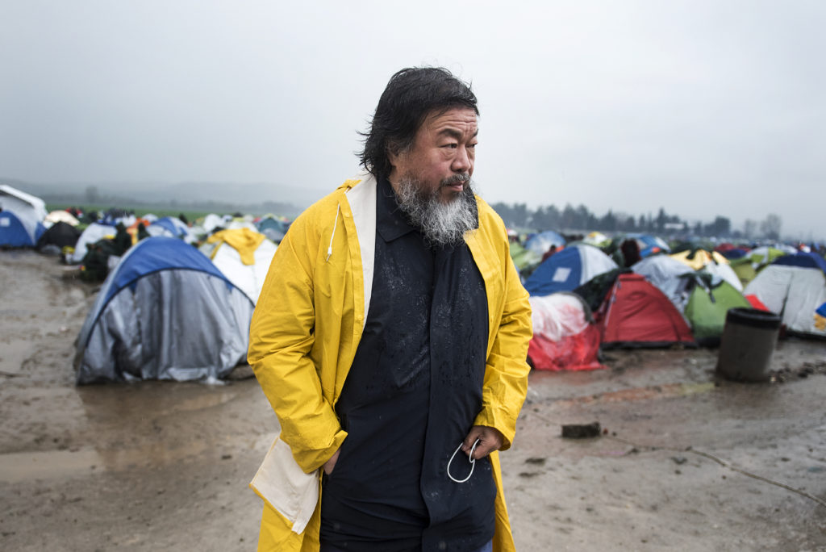

Idomeni, Greece - March 9, 2016. Chinese artist Ai Weiwei during his visit at the makeshift refugee camp of Idomeni in northern Greece, at the Greek-Macedonian border | Shutterstock
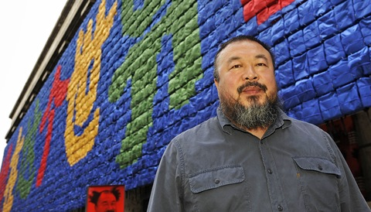

Munich, Germany - October 9, 2009. Chinese artist Ai Weiwei poses in front of his installation called ‘Remembering’ at the ‘Haus der Kunst’ (House of Art) ahead of the exhibition ‘So Sorry’ | Getty Images

